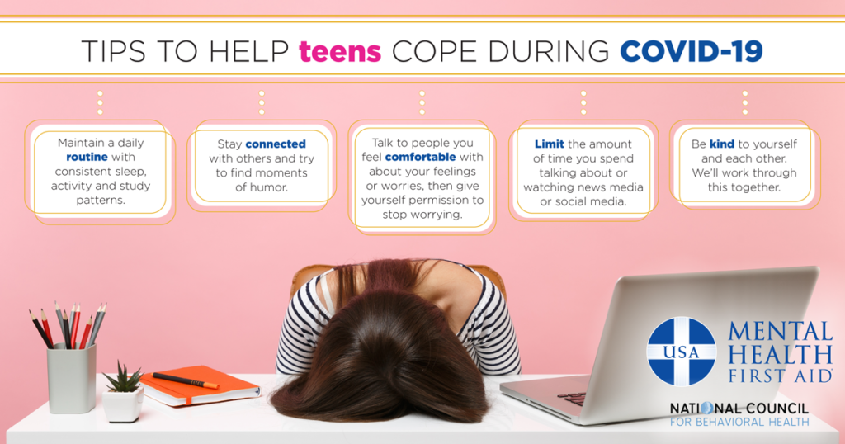
When our world changes quickly and suddenly because of things like COVID-19, it is common to experience changes in our thoughts, feelings and behaviors. Feelings of anxiety, fear or worry are typical in stressful situations.
Typical reactions include:
- Feeling stressed or overwhelmed, frustrated or angry, worried or anxious
- Feeling restless, agitated, on ‘high alert’ or unable to calm down
- Being teary, sad, fatigued or tired, losing interest in usually enjoyable activities or finding it difficult to feel happy
- Worrying about going to public spaces, becoming unwell or contracting germs
- Constantly thinking about the situation, unable to move on or think about much else
- Experiencing physical symptoms such as increased fatigue or other uncomfortable sensations
Everyone reacts differently to stressful situations, so you should not expect any specific reaction. Still, take a few moments to talk with the teens in your life about how they are feeling and what may help them during this difficult time.
Remind them that all of these thoughts and feelings are common right now, and discuss simple self-care strategies that will help manage symptoms of anxiety and depression.
Here are a few tips for mental health and coping from teen Mental Health First Aid:
- Maintain a daily routine with consistent sleep, activity and study patterns.
- Stay connected with others, and try to find moments of humor.
- Talk to people you feel comfortable with about your feelings or worries, then give yourself permission to stop worrying.
- Eat breakfast every morning, plus snacks and meals at regular times throughout the day.
- Limit coffee or energy drinks, as these will increase feelings of anxiety and make it difficult to relax.
- Look for patterns or be aware of situations that make you feel particularly worried or anxious. When you’re in these situations, try relaxation or distraction techniques or ask a family member or friend to help.
- Relieve times of high anxiety with physical activity; engage in regular aerobic exercise (e.g., walk, jog, yoga, dance).
- Limit the amount of time you spend talking about or watching/listening to news media or social media if you are finding information about the COVID-19 situation overwhelming or distressing.
- Do hobbies or activities that you enjoy, calm you down or focus your mind and body. These could be arts and crafts, physical activity, listening to music, reading, journaling, watching TV or movies, or chatting with friends by phone, videoconference or text.
- Understand that the people around you are probably also finding this situation stressful, and they might also be having difficulty controlling their emotions. Try to resolve conflict.
- If you continue to feel overwhelmed, out of control or unable to calm down after a period of weeks, seek help from a mental health professional.
- Take time for yourself.
- Be kind to yourself and each other. We’ll work through this together.

